**ARYAMAN MISHRA**

**19BCE1027**

**LAB 7**

**AIM:** Create a network topology with a CISCO ASA Firewall, Router, Switch, 3 PCs and a Server. Here, a PC is to be connected with ASA Firewall and two PCs are to be connected with switch. Do the following:

1. Create two VLANs

2. Configure the Router, Server and Firewall.

3. Ensure the firewall functionality by demonstrating the packet transmission between the PCs and Server.

4. Apply NAT

5. Use DHCP and ICMP protocols

6. Ping the connected PCs

Experiment:

Create a Topology

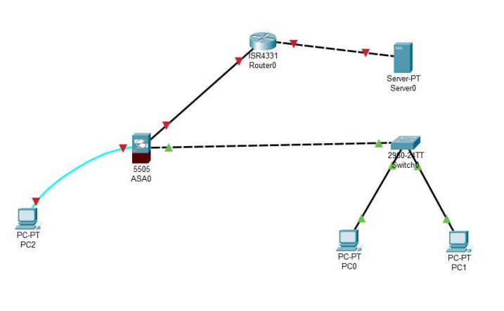

Turn on the routers.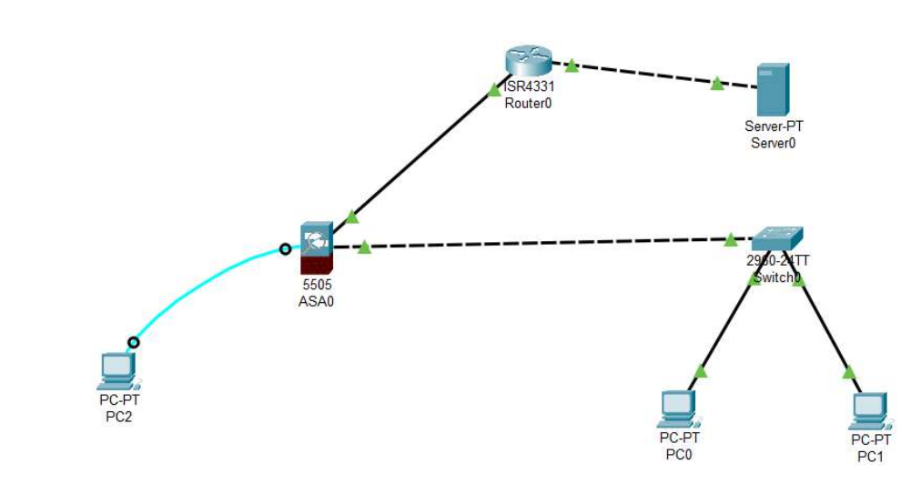Configuring 1 st VLAN with firewall.

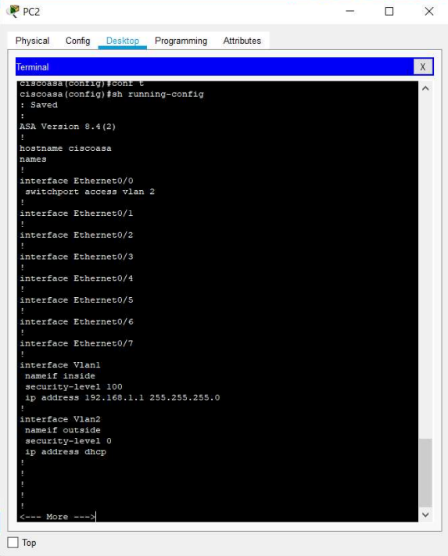

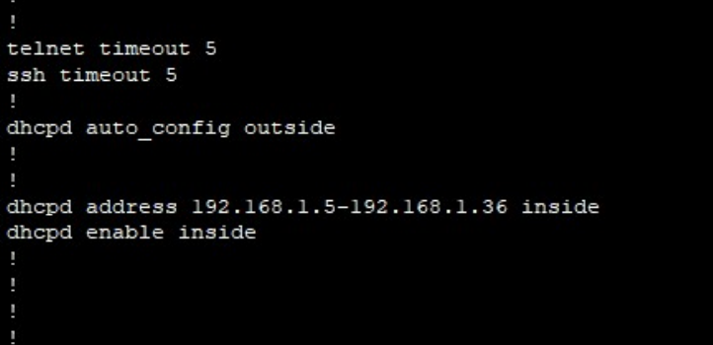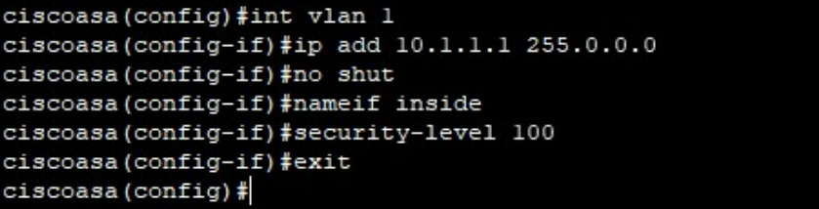

Setting the IP Address on Router 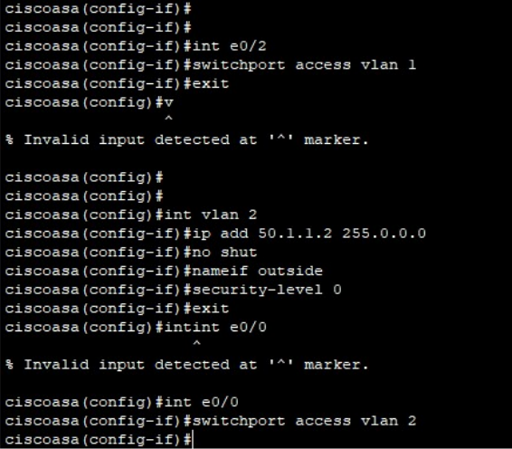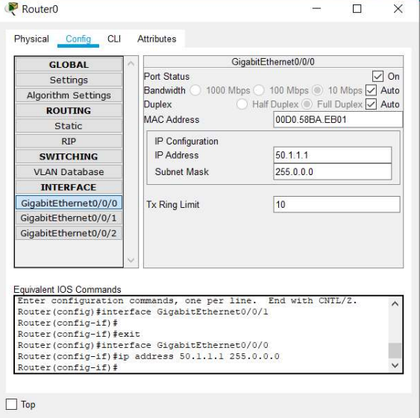

Setting the IP Address on Router 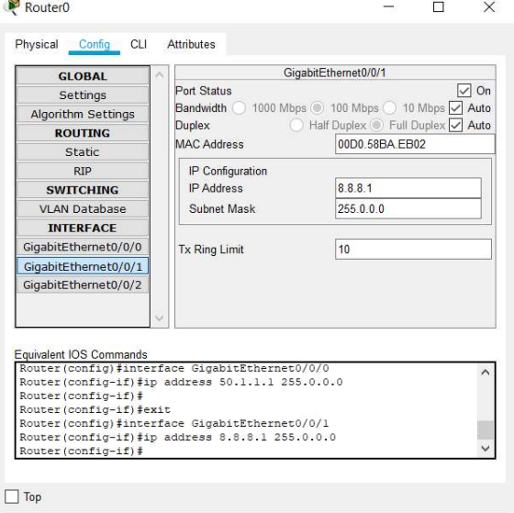

Setting the IP Address on the Server 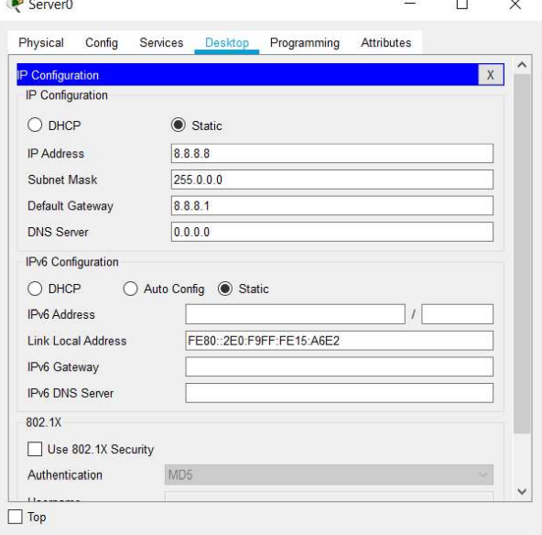

Setting DHCPD range for Firewall via the PC-2 and the DNS IP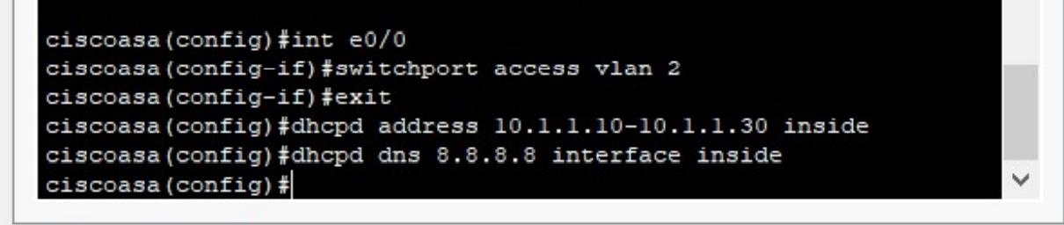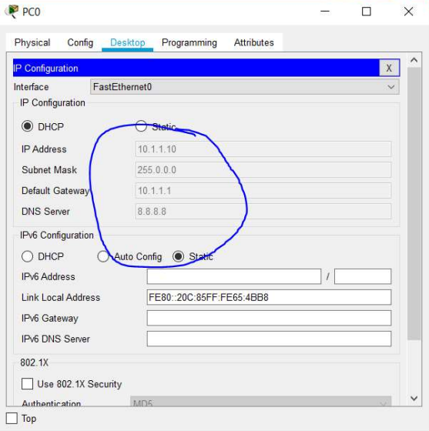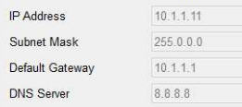

Setting up OSPF on the Router

Setting up OSPF on the Router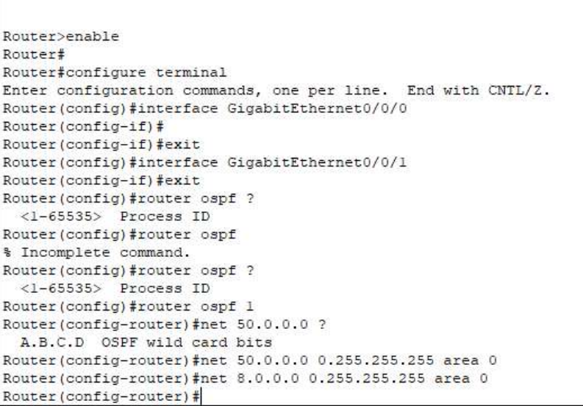

Enable NAT on ASA

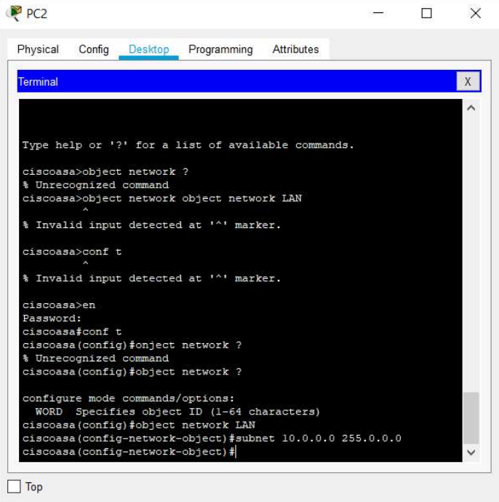

Enable NAT on ASA 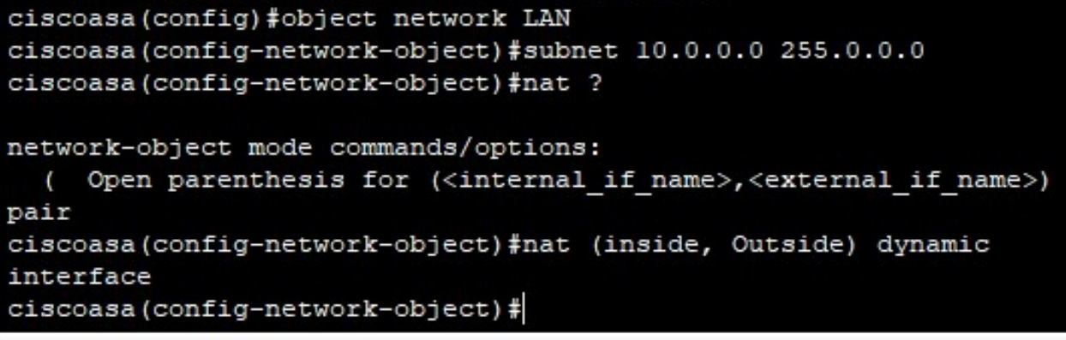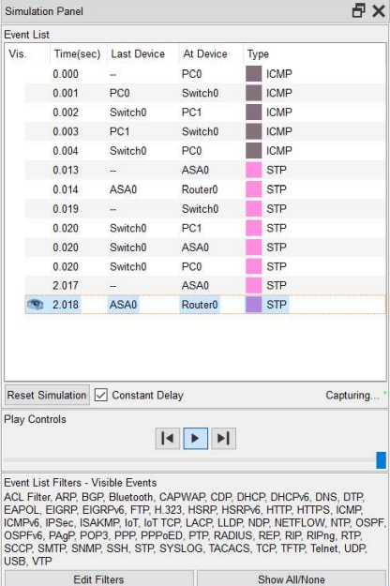

All steps have been successfully implemented and executed.